**Preparation and Maintenance of ZOHO Books for UrbanAura Interiors**

**Project Team members: K.ABINA, R.ABINAYA, U.ALJASMINE, N.ANUPRIYA**

**1. INTRODUCTION**

**1.1 Overview:**

This project is deal with UrbanAura Interiors, a Interior Designing company uses ZOHO Books to effectively manage their financial processes, maintain accurate records, and make informed financial decisions. This integration enhances their overall business efficiency and contributes to their success in the interior design industry.

**1.2 Purpose:**

By maintenance of accounts in ZOHO Books, We have created the Items, Vendors creation, Preparation of Purchase Order, Purchase Invoice, Customer creation, Preparation of Sales order, Sales Invoice, creation of bank account, creation of new accounts, recording journal entries, recording expenses, recording bank receipts and payments and viewing of financial reports like Profit & Loss account, Balance sheet, GST Reports, Journal report, Account receivable summary report, Account payable summary report, etc.,

**2. Problem Definition & Design Thinking**

2.1 Empathy Map

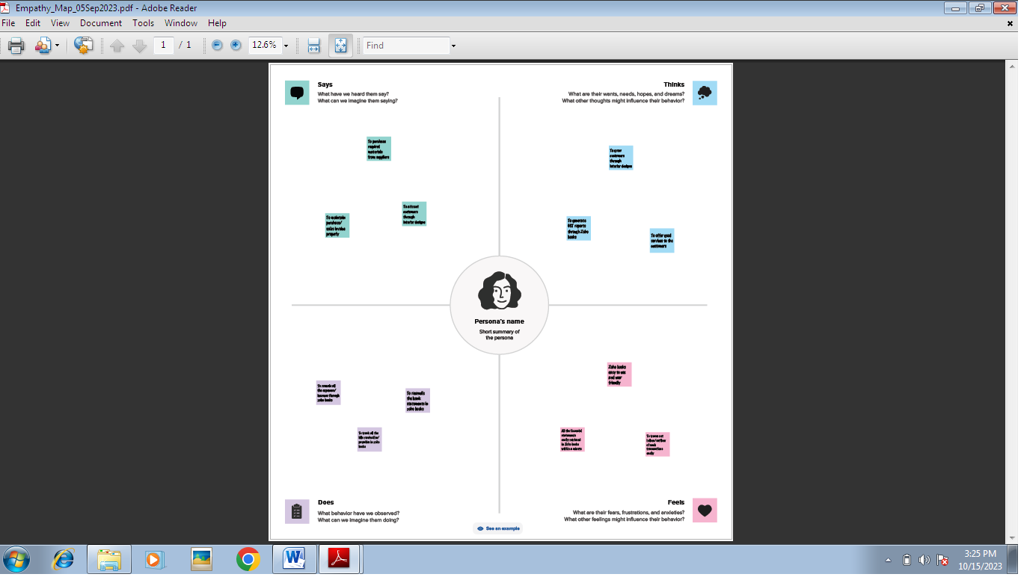

2.2 Ideation & Brainstorming Map

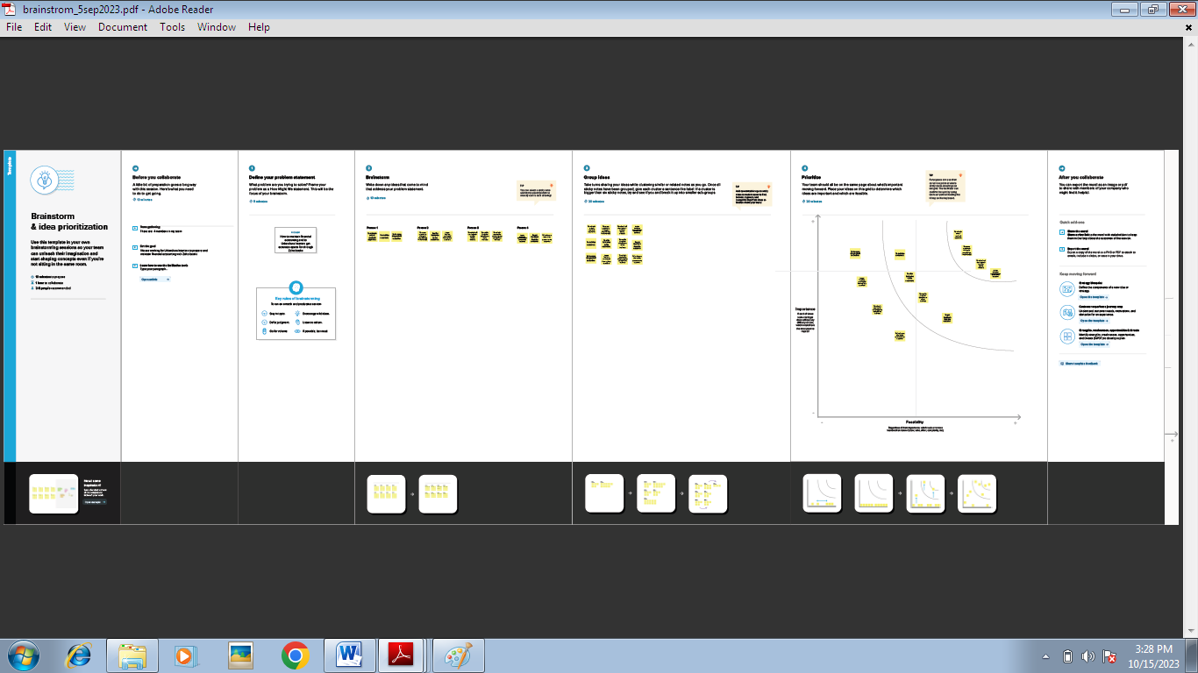

**3. RESULT:**

To Generate the Financial Reports:

1. Profit and Loss Account:

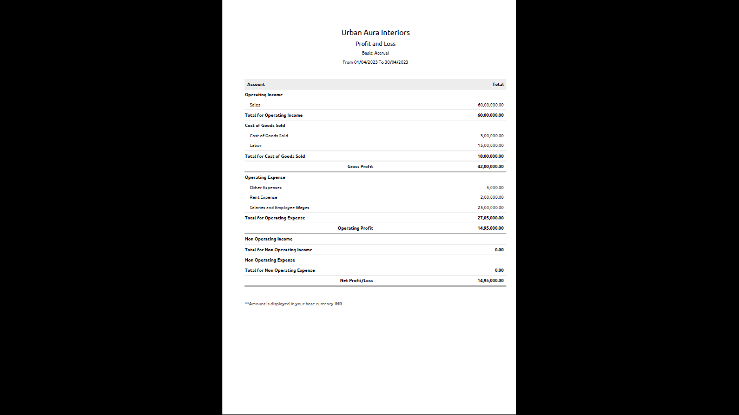

2. Balance Sheet

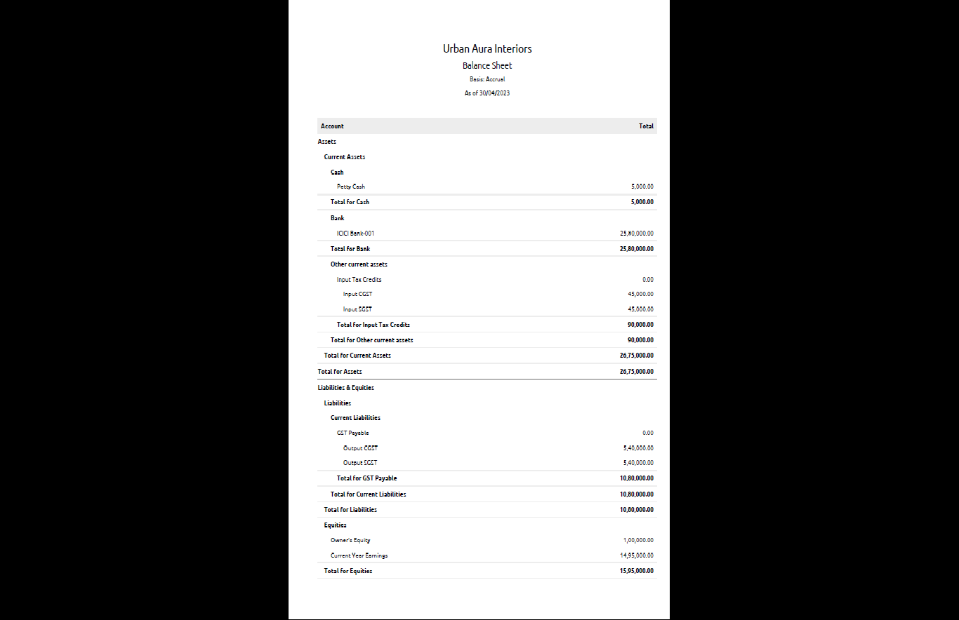

3. GST Reports

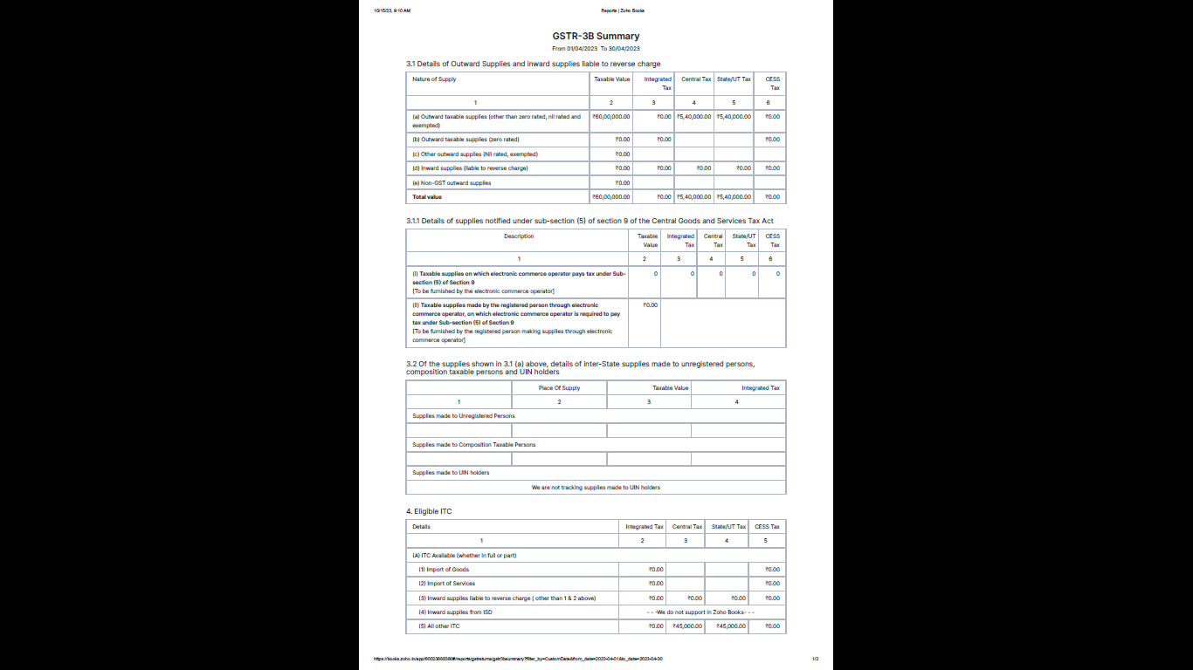

4. Journal Report

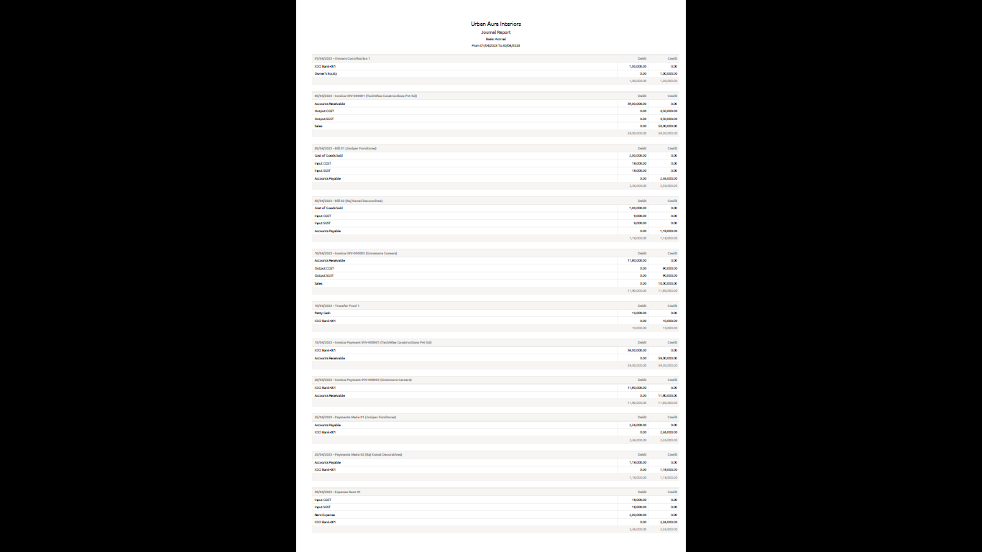

5. Accounts Receivable Summary

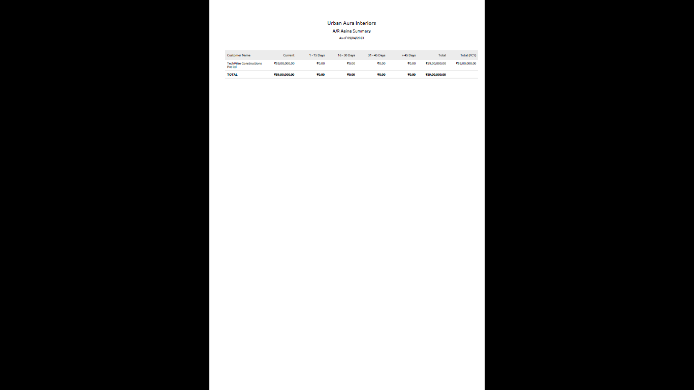

6. Accounts Payable Summary

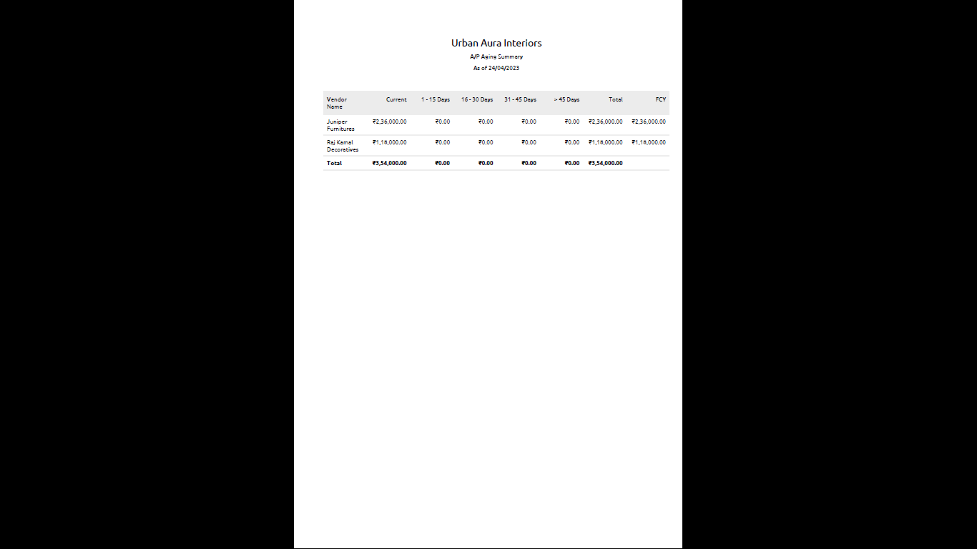

**4. ADVANTAGES & DISADVANTAGES**

List of advantages:

* ZOHO books is cloud based software, so we access the software in any location.
* Creating of Organistion is very easy and user friendly.
* Appearance of software model is very easy to understanding.
* Creation of items, vendors, customers are user friendly while compare with software
* Preparation of purchase order and conversation to purchase Invoice made in a single step.
* Preparation of Sales order and conversation to Sale Invoice made in a single step.
* Default accounting step up is very useful and time saving.
* GST procedure is very easy to enter.
* Getting financial report and tax report in single step.

List of disadvantages:

* ZOHO books is cloud based software, which need internet and other technical facility.
* In absence of internet facility, the working in ZOHO books is very difficult.
* There is no secure in data of the organization.

**5. APPLICATIONS:**

The ZOHO Books is good software in all type of organization and we get better results instantly. We collect the following data and entered in ZOHO Books in various modules like item creation, Vendor creation, customer creation, preparation of Purchase order, Purchase Invoice, sales order, sale Invoice, Making payment to vendors and Expenses, Received amount from Customers.

**Item creation:**

1. Residential Interior Design - Selling Price Rs. 10,000/- per sft.
2. Commercial Interior Design – Selling Price is Rs.20,000/- per sft

It requires below Purchases for the supply of above services:

1. Furniture & Fixture Items ( Cost price is Rs.1000/- per unit)
2. Decorative Accessories (CP is Rs.500/- per unit)
3. Construction and Renovation Materials (CP is Rs.1000/- per unit) Output GST @ 18% is applicable for all the above services & items.

**Vendor creation:**

1. Juniper Furniture (GST registered)
2. Raj Kamal Decorative s (GST registered)
3. Construct Edge Solutions (Non Registered)

**Customer creation:**

1. TechWise Constructions Pvt Ltd (GST Registered).
2. Dream Homes (Non-GST Registered).

**Preparation of Purchase order, Purchase Invoice:**

1. 05-04-2023 Juniper Furnitures- Furnitures and Fixture Items- Qty 200 @ Rs.1000/- each
2. 05-04-2023 Raj Kamal Decoratives- Decorative Accessories – Qty 200
3. 05-04-2023 ConstructEdge Solutions- Construction and Renovation Materials - Qty 200

**Preparation of sales order, sale Invoice:**

1. 05/04/2023 TechWise Constructions – Commercial Interior for 250 sft
2. 10-04-2023 Dream Homes- Residential Interior Designing for 100 sft.

**Making payment to vendors and Expenses:**

1. Employee salaries of total Rs.25,00,000/- paid through bank on 30th April 2023.
2. Office Rent Rs.2,00,000/- excluding GST @ 18% Total Invoice Value Rs.2,36,000/- paid in Bank on 30-04-2023
3. Labour Cost Rs.15,00,000/- paid in Bank on 20-04-2023
4. Other Miscellaneous Expenses Rs.5,000/- paid in cash on 30-04-2023
5. 25-04-2023 Paid to Juniper Furnitures 2,36,000
6. 25-04-2023 Paid to Raj Kamal Decoratives 1,18,000
7. 25-04-2023 Paid to ConstructEdge Solutions 2,00,000

**Received amount from Customers:**

1.15-04-2023 Amount received from TechWise Constructions 59,00,000

2. 20-04-2023 Amount received from Growmore Careers 11,80,000

**6. CONCLUSION:**

In maintain of UrbanAura Interiors accounts in Zoho books is very smart in all the aspects of entries. The basic accounting concept is enough for the operating person(Accountant/Data entry operator). This software is applicable for all types of organization. The entry models of software are easily understood and interest to work. Whatever reports we need, it’s already default in the report models. Totally it’s a good and very useful to the entire entrepreneur with low cost for operating financial department.

**7. FUTURE SCOPE:**

The idea for the founders of ZOHO Books is amazing and very clever. This is a great milestone in the field of accounts maintenance. They offer various plane as per the requirement of the proprietors. It’s a good gift to all the entrepreneurs.